Emergency Action Plan
Table of Contents
Introduction

- Medical Emergencies 3
- Severe Weather 4
- Fire 5
- Bomb Threat/Bomb 6
- Intruder/Suspicious Person(s)
- on the Grounds or in the Building 6
- Active Threat 8
Appendix A Plan View of the Church Property 10
Appendix B Incident/Injury Report 11
Appendix C

Introduction
The purpose of this Emergency Action Plan is to provide for the safety and well-being of the staff and every person who may be on the grounds of Sunrise United Methodist Church. We often think of our church as a safe haven, and we always hope and pray that it will be a safe and secure place for all. However, reality shows us that emergencies of many kinds can occur anywhere, even in our church. A harsh reality is our country’s recent history that proves churches can become targets for those who intend to inflict harm on others.
Advance Preparation
Our church leaders have taken steps to protect persons in our church. We have a state-of-the-art security system, which includes an alarm system that arms at 11 p.m. Monday through Saturday (12 midnight on Sunday nights) and disarms every morning at 6 a.m. The security system also has a five panic-button installation that can have law enforcement at the church within a couple of minutes. Our preschool follows a protocol of maintaining locked doors while the children are in the church. Staff members have special key cards for entry. Anyone else needing to enter the church during preschool hours must ring a doorbell.
It is the responsibility of church staff and leaders, as well as members of the congregation, to be prepared for many types of emergencies. The keys to a successful plan are in its advance preparation and publication. Thoughtful preparation can turn a would-be tragedy into simply an incident and can even save lives. Sunrise Church takes this responsibility seriously. The Trustees have undertaken the task of writing this plan and forming a Safety and Security Committee to oversee its implementation. The Trustees have met with law enforcement, attended meetings on the subject with other churches, and researched documentation from other sources in preparation for writing this document.
This document defines the Safety and Security Committee, which is the foundation for the Emergency Action Plan, and discusses the types of emergencies the church might encounter, plans to prevent such events, and actions to take during each emergency.
Included as Appendix A is a Plan View of the Church Property that shows all rooms, hallways, and exits. All fire alarms and panic buttons are also noted on the plan. Appendix B is an Incident/Injury Report Form to be completed after an emergency event.
Safety and Security Committee
The Safety and Security Committee ensures a whole-church approach. It provides oversight of safety and security related activities, procedures, plans and purchases. It makes recommendations to church leadership. Committee members should be concerned about the big picture of safety and security rather than focusing only on violence in the sanctuary—as important as that is. Because it is an assessment and advisory group rather than a security response team, it can include a range of church members (ages, expertise, and church roles). The Safety and Security Committee should include the following persons:
- Senior pastor
- Chair of the trustees
- Head usher
- Congregational member of law enforcement?
- Congregational fire or emergency personnel?
- Interested volunteer?
- Other?

Duties of the committee will include the following:
- Meet xxxxx xxxx xxxxx (monthly?)
- Publicize the plan to the congregation
- Conduct any drills deemed necessary
- Xxx xx xxxx
- Xxx xx xxxx

Types of Emergencies
The plan includes discussion of the following types of emergencies:
- Medical emergencies
- Severe weather
- Fire
- Bomb threat/bomb
- Intruder/suspicious person(s) on the grounds or in the building
- Active threat
- Others?
- Medical Emergencies
Advance preparation can be very helpful in a medical emergency. Church leaders, staff, and Safety and Security Committee members should maintain a list and know who might be certified in first aid and CPR. They should also be aware of any trained EMS or medical personnel who are a part of the congregation.
For minor medical problems, first aid can be applied. Our church maintains a small first-aid kit, which is located xxxxx xx.
For more severe medical emergencies, a person can be designated to call 911. The person should provide the following information:
- Name and phone number.
- Location of the church (Sunrise United Methodist Church, 5420 Sunset Lake Road, Holly Springs, NC 27540).
- Number of people injured
- Nature of injury or illness
If possible, the person should stay on the line with the responder until help arrives.
If the emergency involves any type of poison, the poison control number is 1-800-222-1222.
Our church has an automated emergency defibrillator (AED), which is located on the wall, in the hallway opposite the kitchen pass-through window, next to the closet. An AED is a portable electronic device that automatically diagnoses the life-threatening cardiac arrhythmias of ventricular fibrillation and pulseless ventricular tachycardia, which is able to treat them through defibrillation. Defibrillation is the application of electricity that stops the arrhythmia, allowing the heart to reestablish an effective rhythm. The equipment is easy to use and will lead the user through the procedure. (Complete information about the AED can be found in the procedure, Automated Emergency Defibrillator, in the Trustee’s book of Maintenance Plans and Procedures.)
The senior pastor should be notified as soon as possible following a medical emergency, and an Incident or Injury Report should be completed.
- Severe Weather
In our geographic location, storms and tornados are the most common types of emergency weather events that might occur suddenly. In the event of storms or electrical storms, church staff should make sure that any persons, especially children, at the church remain inside the building until the danger passes. A severe weather drill should be publicized and conducted at least once a year.
Staff should be aware when a tornado watch is in effect and act accordingly. When a tornado warning is issued via an emergency system, all students, faculty, and staff should immediately cease their activities and direct all persons present to seek shelter in accordance with the directions issues during previous drills. Staff members should calmly issue an audible warning. Activity leaders should direct Sunday school students, church congregation, and activity participants to areas predetermined to provide the best protection from the storm. Anyone in the Pod should be evacuated to the main church building immediately. Leaders should conduct a head count to account for personnel and other individuals at the church during the storm.
The following directives are considered to be the best protection during a tornado or violent storm:
- Seek a small interior room or hallway.
- Stay away from doors, windows, and outside walls.
- Remain in the center of the room or against an inside wall.
- Avoid corners because they attract debris.
- Avoid large rooms with flat or large roof spans.
- Assume a protective crouching position with hands protecting the head if a tornado has been spotted in the immediate vicinity of the church.
Should the severe weather emergency take place while the preschool is in session, needs of the children take priority over others in the building. Preschool staff is trained to care for the children, and the preschool staff will follow its own procedure.
Everyone should remain in the protected area until the warning has been lifted, emergency personnel direct evacuation, or the danger is no longer present. News media weather emergency notification/cancellation should be disregarded. The senior church staff member on campus will issue the all clear after communicating with local authorities.
- Fire
In the event of a fire, the first response should be to activate a fire alarm. Six fire alarms are located throughout the building (see Appendix A, Plan View of the Church Building, which shows the locations of the fire alarms). Someone should also call 911 and state the type of fire and where it is located in the building. Only then should anyone attempt to use a fire extinguisher, if appropriate and possible.
Fire is an emergency situation that might require immediate evacuation. If a fire should occur during worship times, ushers and church staff will direct attendees to exit the building and retreat in an orderly fashion to the far end of the parking lot, nearest the back lot of the veterinary clinic. Teachers should take a roll call head count, and staff should account for people and staff.
If a fire emergency occurs during times when children are being cared for, individuals should not try to retrieve their children from their classrooms. They will be cared for by staff/teachers who have their own classroom exit plans. The children will be brought to their parents at the designated evacuation meeting place.
Individuals should not try to get in a car and leave the premises. Such actions can cause traffic jams that might delay or prevent emergency vehicles from arriving.
An all clear signal should be given when the emergency is over, indicating when it is safe to return to the church.
- Bomb Threat/Bomb
A bomb emergency exists when a bomb threat has been received, a bomb has been located, or a bomb has exploded.
A bomb threat or bomb in the church building should be handled much the same way as a fire evacuation. After calling 911, all persons in the building should be evacuated in an orderly fashion to the far end of the parking lot, nearest the veterinary clinic. Teachers should take a roll call head count, and staff should account for people and staff.
All persons should cease any radio communications on site. Persons on site must be aware of a potential second device and stay away from a suspected area or explosion area, buildings, or vehicles.
If a bomb/bomb threat emergency occurs during times when children are being cared for, individuals should not try to retrieve their children from their classrooms. They will be cared for by staff/teachers who have their own classroom exit plans. The children will be brought to their parents at the designated evacuation meeting place.
Individuals should not try to get in a car and leave the premises. Such actions can cause traffic jams that might delay or prevent emergency vehicles from arriving.
Once out of the building, all persons should remain there until an all clear signal is given when the emergency is over, indicating when it is safe to return to the church.
- Intruder/Suspicious Person(s)
- on the Grounds or in the Building
If a suspicious person(s) is seen on the grounds of the church, staff or other persons in the building should observe the intruder(s) to determine why they are on the grounds and if law enforcement support is needed. Because we are not a large church, we often have staff members who are working alone at the church. Our pastors, administrative assistant, music staff members, and others may be uncomfortable if they spot an unfamiliar person on the grounds. If a determination to reach out for law enforcement help is made, the person making the determination should call 911 and make sure that all entrances to the church are locked. When law enforcement arrives, the observer should provide information to the first responders.

If a suspicious or irrational person is inside the church building, a senior staff member, if available, should engage the individual to determine whether he or she has legitimate business with the church and can be directed to someone who can further assist the person. If a senior staff member is not available, any responsible person should engage the person quickly to determine if a security response is necessary. Two church members are better than one. The person(s) should be professional and polite as questions posed to a disruptive or agitated individual can either increase or decrease the chances that the individual will calm down. Examples of questions include the following:

- “How may I help you?”
- “May I help you find who you are looking for?”
- “Excuse me, may I talk with you for a moment?”
- “Let me see if I understand what you are saying.”
- “What’s the matter; how may I help”
- “I’m sorry. I’m not sure how I can help you.”

If the senior staff member or other person feels uncomfortable and believes that the individual might present a danger, he or she should communicate with anyone else in the building to call 911, or he or she can engage one of the five panic buttons in the church building, which will automatically call the police.
The panic buttons are located in the church building as follows:
- Classroom corridor, near exterior exit, above telephone
- Preschool office, near entry door, left of telephone
- Front office, above desk, left wall, right of window
- Sanctuary, near sound booth, roadside wall
- Sanctuary, under top of lectern, at the front of the sanctuary

(See Appendix A, Plan View of the Church Property, which shows the location of all panic buttons.) (More information on the panic buttons can be found in the Safety and Security Procedure, in the Trustee’s book of Maintenance Plans and Procedures.)

In either of these situations, the person(s) who observed the suspicious person/intruder should fill out an Incident Report (Appendix B).
- Active Threat
An active threat is an individual(s) with a weapon, usually a gun, who is threatening people with the intent of bodily harm. An active shooter is an individual(s) actively engaged in shooting people with the attempt to harm or kill them in a confined and populated area, typically through the use of firearms. These events are unpredictable and evolve quickly, and individuals must be prepared both mentally and physically to deal with the situation. Law enforcement is usually required to control and end the situation.
Events can evolve quickly. The safety of our congregation might depend upon our preparedness. Individual preparedness might include the following mindfulness:
- Be aware of the environment and any possible dangers.
- Always take note of the nearest exits and possible hiding places.
- Be prepared to call 911 and know the locations of the panic buttons.
- Be prepared to give an accurate report to responder(s):
- The location of the active shooter(s)
- The number of shooter(s), description of the shooter(s), including physical features, clothing, race, and gender
- The number and type of weapons held by the shooter
- The number of potential victims and/or hostages

According to the guidelines of the United Methodist Church (What to Do When the Unthinkable Happens), the following actions should be taken in an active shooter situation:

RUN, and escape, if possible.
- Safely get out of the church at the nearest exit.
- Encourage others to go with you, but do not hesitate.
- Leave your belongings behind. What is important is your safety.
- Warn and prevent individuals from entering an area where the active shooter might be.
- Activate one of the panic buttons or call 911 when you are safe, and describe shooter, location, and weapons. (Using one of the panic buttons is probably the faster option, if you can get to one safely. In a test coordinated with local law enforcement, police arrived in under two minutes when the panic button was activated.)

(See Appendix A, Plan View of the Church Property, which shows the location of all panic buttons.)

HIDE, if escape is not possible.
- Take shelter in a safe room or closet, under furniture, behind a large object or outside. (Barricade the door from the inside with heavy furniture or objects, if possible, and stay away from the door. (Local law enforcement identified our choir closet at the back of the sanctuary as an excellent place to hide if escape is not possible.)
- Silence ringers on mobile devices and make sure they won’t vibrate.
- Lock and block doors, close blinds, and turn off lights.
- Remain quiet.
- Try not to hide in groups (unless in a closet).
- Act quickly.
- Stay in place until law enforcement gives you the all clear.

FIGHT as an absolute last resort.
- When no other options are possible, commit to your actions and act as aggressively as possible against the shooter.
- Recruit others to ambush the shooter with makeshift weapons such as chairs, fire extinguishers, scissors, and books to distract and disarm the shooter.
- Be prepared to cause severe or lethal injury to the shooter.

Policies
Neither the United Methodist Church nor the state of North Carolina have a published policy on open carry or concealed carry of weapons in churches, thus leaving the decision up to the individual church whether or not to allow these types of activity.

Appendix 1
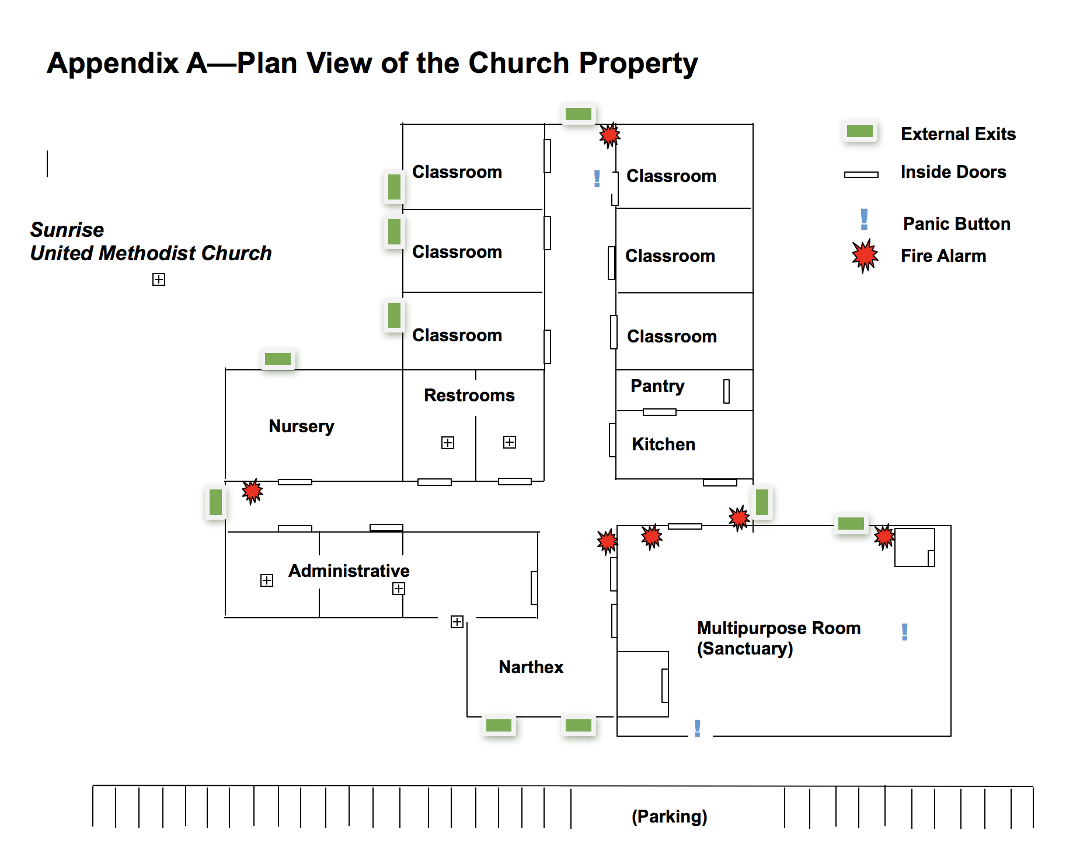

Appendix 2
Appendix B—Incident/Injury Report

Date of occurrence Time

Incident Injury Other

Location on church property

Person(s) involved (injured, assistance rendered, staff involved)

Were police or other law enforcement officials notified? Yes No

Describe incident

Witnesses to incident

Signature of individual reporting the incident

Date

